COOL ROOF COATINGS GUIDE SPECIFICATIONS

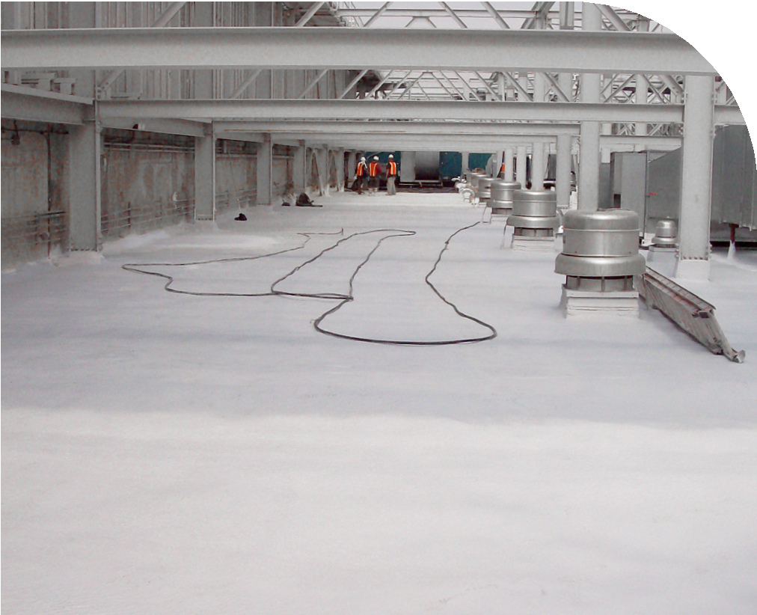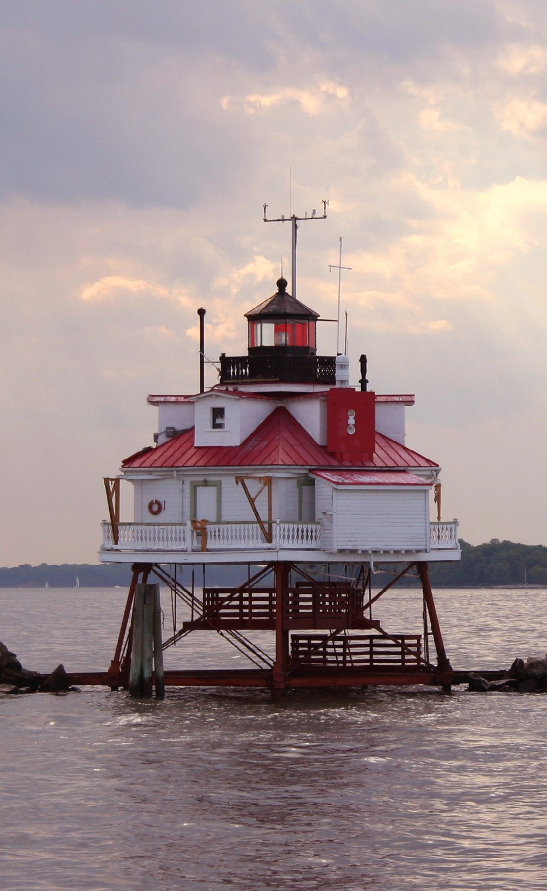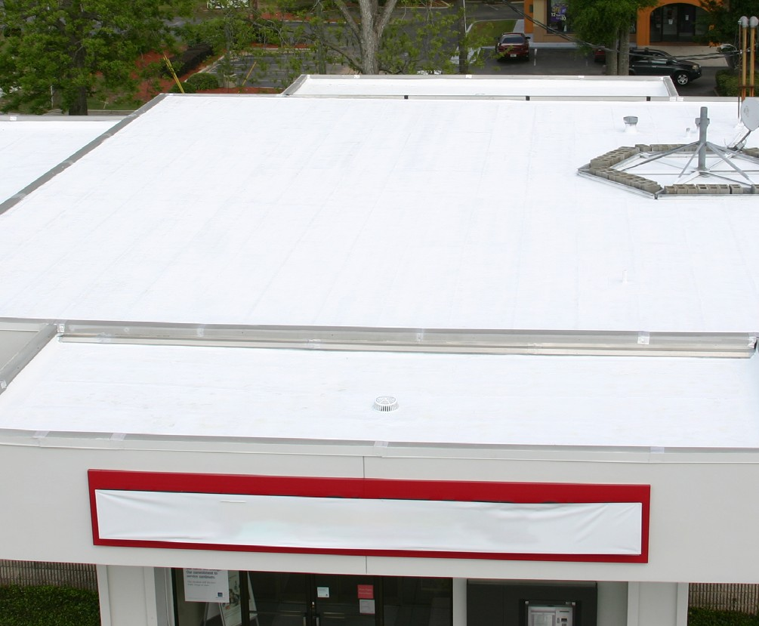
SECTION 07 05 13
FIELD-APPLIED FLUOROPOLYMER COOL ROOF COATINGS

THIS GUIDE SPECIFICATION IS WRITTEN
ACCORDING TO CSI SECTIONFORMAT®
FOR THE LATEST UPDATES,
PLEASE VISIT KYNARAǪUATEC.COM
TO SPEAK WITH A KYNAR AǪUATEC® REPRESENTATIVE,
CALL 1-800-KYNAR-50

SECTION 070513 - COOL ROOF COATINGS
Disclaimer - Please consult Arkema’s disclaimer regarding the use of Arkema’s products on
http://www.arkema.com/en/products/product-safety/disclaimer/index.html
Kynar®, Kynar 500® and Kynar Aquatec® are registered trademarks of Arkema Inc.
©2017 Arkema Inc. All rights reserved.
The paint systems specified in this Section are based on the use of Kynar Aquatec® fluoropolymer based coatings as the basis of design. Not intended for flat roof applications.
Kynar Aquatec® fluoropolymer is an innovative platform of emulsions, which are used by paint formulators to make premium weatherable water-based coatings. Coatings formulated with these emulsions can provide the durability and performance of traditional Kynar 500® resin-based coatings. They can easily be applied to a variety of substrates, including metals, plastics, wood, concrete, masonry, fiber cement, stucco, textiles, and previously painted surfaces.

PART 1 - GENERAL

  - SUMMARY
    - Section Includes:
      - Field-applied, water-based, fluoropolymer liquid coating system on existing roof surfaces.
    - Related Requirements:
The list of related sections below is only an example. If including the Related Section paragraph, be sure to delete section from the list below that are not part of the project, and add sections which are part of the project but not listed. Verify section titles.
      - Division 01 Section "Sustainable Design Requirements".
      - Division 06 Section "Exterior Rough Carpentry".
      - Division 06 Section "Exterior Finish Carpentry".
      - Division 07 Section "Metal Shingles".
      - Division 07 Section "Roof Tiles".
      - Division 07 Section "Metal Wall Panels".
      - Division 07 Section "Metal Roof Panels".
      - Division 07 Section "Built-Up Bituminous Roofing".
      - Division 07 Section "Modified Bituminous Membrane Roofing".
      - Division 07 Section "Elastomeric Membrane Roofing".
      - Division 07 Section "Sheet Metal Roofing".
      - Division 07 Section "Sheet Metal Flashing and Trim".
      - Division 07 Section "Roof Specialties".

  - DEFINITIONS
    - Kynar Aquatec® ARC Latex: Hybrid dispersion containing 70% by weight Kynar® fluoropolymer resin and 30% acrylic resin.

Kynar Aquatec® ARC latex is a hybrid dispersion containing, on polymer solids, 70% by weight Kynar® fluoropolymer resin and 30% proprietary acrylic resin. This ratio is similar to those used in baked metal finishes based on Kynar 500® fluoropolymer, which have a 50-year track record of superb weatherability in architectural applications. After 17 years south Florida exposure, waterborne coatings based on prototype versions of Kynar Aquatec® ARC latex are confirming weathering performance comparable to 70% Kynar 500® fluoropolymer finishes
    - Kynar Aquatec® FMA-12 Latex: Fluorine Modified Acrylic Resin
Kynar Aquatec® FMA-12 latex is a hybrid dispersion containing, on polymer solids, 50% by weight Kynar® fluoropolymer resin, and 50% proprietary acrylic resin. Accelerated weathering results confirm superior durability of FMA-12 latex compared to premium grade acrylics. Kynar Aquatec® FMA-12 latex paints with a latex minimum film formation temperature (MFFT) in the 10-12°C range are designed for field-applied elastomeric roofing, building restoration and premium architectural coatings. Coatings based on this product show excellent adhesion on numerous substrates including fluoropolymer coated metal roofing.
    - DTM: Direct to Metal.
    - LEED®: Leadership in Energy and Environmental Design (LEED®) is a sustainable (green) building rating systems developed by the U.S. Green Building Council (USGBC).
    - VOC: Volatile Organic Compounds.
    - SRI: Solar Reflective Index.

  - REFERENCE STANDARDS
    - ASTM International (ASTM)
      - ASTM B 117 – Practice for Operating Salt Spray (Fog) Apparatus.
      - ASTM D 412 - Standard Test Methods for Vulcanized Rubber and Thermoplastic Elastomers-Tension.
      - ASTM D 1653 - Standard Test Methods for Water Vapor Transmission of Organic Coating Films.
      - ASTM D 1654 – Standard Test Method for Evaluation of Painted or Coated Specimens Subjected to Corrosive Environments.
      - ASTM D 2240 - Standard Test Method for Rubber Property-Durometer Hardness.
      - ASTM D 2244 – Test Method for Calculation of Color Differences from ASTM D 2370 - Standard Test Method for Tensile Properties of Organic Coatings.
      - ASTM Instrumentally Measured Color Coordinates.
      - ASTM D 2697 - Standard Test Method for Volume Nonvolatile Matter in Clear or Pigmented Coatings.
      - ASTM D 4214 – Test Methods for Evaluating Degree of Chalking of Exterior Paint Films.
      - ASTM D 5201 - Standard Practice for Calculating Formulation Physical Constants of Paints and Coatings.
      - ASTM D 6083 - Standard Specification for Liquid Applied Acrylic Coating Used in Roofing.
      - ASTM E 96 - Standard Test Methods for Water Vapor Transmission of Materials.

  - PReINSTALLATION MeeTINGS
    - Section [013000 - Administrative Requirements] <insert section number and title>: Requirements for coordination.
    - Convene minimum one week prior to commencing Work of this Section.
      - Attendees: Contractor, installer, [and manufacturer].
      - Review installation instructions and conditions at site.

  - SUBMITTALS
    - Section [013300 - Submittal Procedures] <insert section number and title>: Requirements for submittals.
Product data sheets and samples are available from a Kynar Aquatec® coating formulator and can be accessed through the following web site: http://www.KynarAquatec.com.
    - Product Data: Submit data on finishing products and coatings.
Color or colors may actually be specified in other Sections based on various materials and products being painted. Cross reference these sections.
    - Samples for Initial Selection:
      - Submit [two] [ ] <insert item>, [6 by 6 inches (150 by 150 mm)] [ by
( by )] in size illustrating color, gloss, and texture for each color selected and each material to be coated.
    - Samples for Verification:
      - Submit [two] [ ] <insert item>, [6 by 6 inches (150 by 150 mm)] [ by
( by )] in size illustrating color, gloss, and texture for each color selected and each material to be coated.
Kynar Aquatec® emulsion is a copolymer of vinylidene fluoride. Finishes based on Kynar Aquatec® emulsion are formulated by Kynar Aquatec® trademark licensees and contain, in addition to Kynar Aquatec® emulsion, high quality pigments, and performance additives. According to the trademark licensing agreement, a minimum of 25 percent by weight fluoropolymer resin solids on total resin solids using Kynar Aquatec® emulsion is required. These high quality coating systems have a proven history when exposed to severe ultraviolet radiation for more than 17 years.
Request certificates from the Kynar Aquatec® trademark licensee to ensure that coatings contain Kynar Aquatec® emulsion manufactured by Arkema Inc. at the proper percent of fluoropolymer solids.

e. Certificates: Certify coatings are manufactured with minimum [50%] [25%], by weight, Kynar Aquatec® fluoropolymer resin and meet or exceed specified requirements of this section.

- Test and evaluation Reports:
  - Submit preconstruction adhesion test report.
See Cool Roof Rating Council (CRRC) searchable rated products directory at www.coolroofs.org. Textured Coatings of America has CRRC rated coatings.

  - Submit Cool Roof Rating Council coating rating report.
    - Indicate initial and 3-year solar reflectance, thermal emittance, and solar reflectance index.
- Manufacturers' Instructions: Submit manufacturer's installation instructions.
- Field Quality Control Submittals:
  - Submit manufacturer's field service report.
- Sustainable Design Submittals
  - Section [018113 - Sustainable Design Requirements - LEED® V4] <insert section number and title>: Requirements for sustainable design submittals.
  - Manufacturer's Certificate: Certify products meet or exceed specified sustainable design requirements.
The following are for LEED® V4.
    - Heat Island Reduction Certificate:
      - Manufacturer's cool roof certificate.
    - Building Life-Cycle Impact Reduction, Option 3.
    - Persistent, Bioaccumulative, and Toxic (PBT) Source Reduction - Lead and Cadmium.
      - Certify reduction of these materials.
- Qualification Statements: Submit manufacturer qualifications.

  - CLOSEOUT SUBMITTALS
    - Section [017000 - Execution and Closeout Requirements] <insert section number and title>: Requirements for submittals.
    - Operation and Maintenance Data: Submit data on cleaning, touch-up, and repair of coated surfaces.

  - MAINTENANCE MATERIALS
    - Section [017000 - Execution and Closeout Requirements] <insert section number and title>: Requirements for maintenance materials.
    - Supply [1 quart (1 L)] [1 gallons (4 L)] <insert quantity> of each color, type, and surface texture; store where directed.
    - Label each container with color, type, texture, room locations, in addition to manufacturer's label.

  - QUALITY ASSURANCE
Retain one of the 2 Manufacturer Qualification options and delete the other. Keep the 2nd option for a non-proprietary, publicly bid project.
    - Manufacturer Qualifications: Company specializing in manufacture of coatings specified in this Section that is a [Kynar Aquatec® licensee] [licensee of the resin manufacturer].
Edit Part 2 Products before editing the Applicator Qualification requirements below.
    - Applicator Qualifications: Company specializing in applications of coatings specified in this Section and approved by coating manufacturer.
    - Preconstruction Adhesion Testing:
Include adhesion testing to ensure coating compatibility with substrates. This test is for use on metallic substrates. Use on other substrates may not give meaningful results. Adhesion test is destructive. Test area must be repaired after testing.
      - Apply first coat to substrate. Test coating adhesion by ASTM D 3359.
        - Perform minimum three tests.
          - Acceptance Criteria: Minimum 4A, each test.
        - Comply with manufacturer's instructions for meeting specified adhesion.
        - Repeat test until meeting acceptance criteria.
        - Remove or repair damaged coating.

  - DELIVERY, STORAGE, AND HANDLING
    - Delivery and Acceptance Requirements:
      - Deliver materials in manufacturer's original unopened containers with labels intact and legible.
    - Storage and Handling Requirements:
      - Store materials on clean raised platforms with weather protective covering when stored outdoors. Store coatings in a cool dry area.
      - Protect materials against damage by construction traffic.

  - FIELD CONDITIONS
    - Section [016000 - Product Requirements] <insert section number and title>: Environmental conditions affecting products on site.
    - Apply coatings only when temperature of surfaces to be coated and surrounding air temperatures are between 50 and 100 °F (10 and 38 °C). Substrate should be 5 °F above the dew point.

    - Do not apply coatings in snow, rain, fog, or mist. Do not apply coatings if precipitation is expected within 24 hours or if the air or substrate temperature is expected to drop below 35 °F within 48 hours.

  - WARRANTY
    - Section [017000 - Execution and Closeout Requirements] <insert section number and title>: Requirements for warranties.
    - Coating Applicator’s Warranty: Applicator agrees to repair finish or replace coated items that demonstrate deterioration of field-applied high performance latex coatings within warranty period indicated.
      - Tier [1] [2] Exposed Coating containing a minimum of [50] [25] % of fluoropolymer resin solids from Kynar Aquatec® emulsion based on total resin solids it the formulation. Deterioration includes but is not limited to:
        - Color fading exceeding [5] [10] Delta E Hunter units per ASTM D 2244.
        - Peeling, checking, or cracking of coating adhesion to metal.
        - Chalking exceeding [No. 6 (Colors)] [No. 8 (Whites)] per ASTM D 4214.
      - Warranty Period: [10] [15] [20] years from date of substantial completion.

PART 2 - PRODUCTS

  - COATING PERFORMANCE
Select one or more of the following systems according to the project requirements. If selecting more than one system, clearly indicate the limits of each system and identify each system on the drawings.
To meet the performance criteria of a Tier 1 coating, these coatings must contain a minimum of 50% of fluoropolymer resin solids based on the total amount of resin solids in the paint formulation. 50% fluoropolymer resin solids coatings based on Kynar Aquatec® emulsion typically carry the longest term performance warranties from the coatings manufacturer.
Only a coating that contains Kynar Aquatec® emulsion can be branded a Kynar Aquatec® coating and should be clearly labeled with the percent of fluoropolymer resin solids on total resin solids.
    - Tier 1: Kynar Aquatec® emulsion-based, field-applied, water-based, fluoropolymer liquid coating system on existing roof and exterior surfaces that comply with the following performance criteria:
      - After 4000 hours of QUV-B exposure per ASTM G154 cycle 2 with UVB-313 lamps and a minimum irradiance of 0.67 W/m2/nm, or a modified cycle 2 with UVB-313 lamps, 8 hours UV at 60 (+/- 3) °C black panel temperature; 4 hours condensation at 50 (+/- 3) °C black panel temperature and a minimum irradiance of 0.67 W/m2/nm, the exposed coating deterioration does not exceed the following criteria:
        - Color fading exceeding 5 Delta E Hunter units per ASTM D 2244.
        - Peeling, checking, or cracking of coating adhesion to substrate.
        - Chalking exceeding No. 6 (whites) or No. 8 (colors) when tested per ASTM D 4214.

To meet the performance criteria of a Tier 2 coating, these coatings must contain a minimum of 25% of fluoropolymer resin solids based on the total amount of resin solids in the paint formulation. 25% fluoropolymer resin solids coatings based on Kynar Aquatec® emulsion and routinely outperform acrylic coatings.
Only a coating that contains Kynar Aquatec® emulsion can be branded a Kynar Aquatec® coating and should be clearly labeled with the percent of fluoropolymer resin solids.
    - Tier 2: Kynar Aquatec® emulsion-based, field-applied, water-based, fluoropolymer liquid coating system on existing roof and exterior surfaces that comply with the following performance criteria:
      - After 4000 hours of QUV-B exposure per ASTM G154 cycle 2 with UVB-313 lamps and a minimum irradiance of 0.67 W/m2/nm, or a modified cycle 2 with UVB-313 lamps, 8 hours UV at 60 (+/- 3) °C black panel temperature; 4 hours condensation at 50 (+/- 3) °C black panel temperature and a minimum irradiance of 0.67 W/m2/nm exposed coating deterioration includes but is not limited to:
        - Color fading exceeding 10 Delta E Hunter units per ASTM D 2244.
        - Peeling, checking, or cracking of coating adhesion to substrate.
        - Chalking exceeding No. 6 (whites) or No. 8 (colors) when tested per ASTM D 4214.

  - SUSTAINABLILITY CHARACTERISTICS
LEED® V4 applies to exterior, although only Healthcare and Schools. Confirm compliance with CDPH room testing and CARB 2007 or SCAQM Rule 1113.
    - Environmental Quality Credit: Low-Emitting Materials, Paints.
LEED® V4, Option 1, to meet initial and 3-year SRI. Review different values for steep and low slope roofs to specify correct value.
    - Sustainable Sites Credit: Heat Island Reduction.

Slope | Minimum Initial SRI | Minimum 3-Year Aged SRI
Less than or equal to 2:12 | 82 | 64
Greater than 2:12 | 39 | 32
    - Material Resources Credit: Building Life-Cycle Impact Reduction, Option 3.
      - Coating allows existing roof to be retained rather than replaced with new materials.
    - Material Resources Credit: Persistent, Bioaccumulative, and Toxic (PBT) Source Reduction - Lead and Cadmium.

  - PERFORMANCE REQUIREMENTS
    - Performance-Criteria:
      - Composition: Coating compositions produced by Kynar Aquatec® licensee that contains resin solids, where at least 25% by weight of total resin solids present is Arkema fluoropolymer.

Always keep the resin manufacturer paragraph below. Each fluoropolymer coating system must contain Kynar Aquatec® resin.
Kynar Aquatec® is an innovative platform of emulsions, which are used by paint formulators to make premium weatherable water-based coatings. Coatings formulated with these emulsions can provide the durability and performance of traditional Kynar 500® resin-based coatings. They can easily be applied to a variety of substrates, including metals, plastics, wood, concrete, masonry, fiber cement, stucco, textiles, and previously painted surfaces.
    - Manufacturer, Resin: Subject to compliance with requirements, provide coating systems containing Kynar Aquatec® latex by Arkema Inc.

  - COOL ROOF COATING SYSTEMS
    - General: [Spray] [Roller] [Brush]-applied, water based, Kynar Aquatec® emulsion-based, fluoropolymer finish
      - Resin: Polyvinylidene Fluoride fluoropolymer.
See www.kynaraquatec.com for an up-to-date list of coatings.
Acrymax Technologies, Inc., AF-4400 finish coat can be applied over Asphalt, Concrete, Single Ply Membranes, Metal, and cementious siding primed with AF-130 series coatings or finished with an AF- 130 series complete system.
    - Acrymax fluoropolymer coating by Acrymax Technologies Inc.
Consult manufacturer to determine recommended primer. First two options are for metal substrates. Third option includes coating systems suitable for multiple roofing substrates.
      - Primer: [Acrymax® PC-125 Rust Inhibitive Primer] [Acrymax® PC-535 Direct-to-Metal Elastomeric Rust Inhibitive Coating] [Acrymax® AF-130 Elastomeric Coating System], as recommended by manufacturer to suit substrate.
      - Top Coat: Acrymax® AF-4400 acrylic modified fluoropolymer coating.
        - Solids by Volume: 37.2%.
        - Solids by Weight: 54.7%
        - VOC: Less than 50 g/l.
        - Dry Film Thickness: 6.4 to 8.0 mils (0.16 to 0.20 mm).
APV Engineered Coatings, eCoolRoof® can be applied to Wood, Stucco, Aluminum, Vinyl, CMU, Masonry, Fiber Cement.
    - eCoolRoof ® by APV Engineered Coatings:
      - Elastomeric Acrylic Primer: ASTM D 6083; water based, low VOC.
        - Product: APV eCoolRoof® P-1498 (elastomeric acrylic basecoat).
        - Volume Solids: 51.34%, ASTM D 5201.
        - Permeance: Less than 1.0, ASTM E 96.
        - Elongation: Greater than 400, ASTM D 412.
e. VOC: Wet: 0.19 lb/gal (22.78 g/l); Dry 0.34 lb/gal (40.77 g/l).

f. Substrate: [PVC] [EPDM] [TPO] [Metal] [Modified Bitumen] [Concrete] [Polyurethane Foam].

      - High Performance Coating: ASTM D 6083; low VOC.
        - Product: APV eCoolRoof® P-1494 (modified fluoropolymer roof coating).
        - Volume Solids: 43.21%, ASTM D 5201.
        - Permeance: Less than 1.0, ASTM E 96.
        - Elongation: Greater than 200%, ASTM D 412.
e. VOC: Wet: 0.35 lb/gal (41.97 g/l); Dry 0.69 lb/gal (82.74 g/l).
****** [OR] ******
Quest Construction Products Kymax® basecoat and Kymax® topcoat can be applied to PVC, standing seam and corrugated metal roofs, sprayed-in-place polyurethane foam, modified bitumen, PVC, TPO, Hypalon® rubber and EPDM.
    - KYMAX® by Quest Construction Products:
      - Elastomeric Acrylic Basecoat High solids elastomeric acrylic coating.
        - Product: Kymax® Basecoat, elastomeric acrylic waterproofing.
        - Volume Solids: 50%, ASTM D 2697
        - Permeance: 2.7 perm at 22 dry mils (154 ng/Pa x s x sq. m at 0.56 mm), ASTM E 96.
        - Hardness: 60 to 70 Shore A; ASTM D 2240.
        - Elongation: Greater than 200%, ASTM D 412.
        - Dry Film Thickness: 10 to 30 mils (0.25 to 0.75 mm).

Substrate: [PVC] [EPDM] [TPO] [Metal] [Modified Bitumen] [Hypalon® rubber] [Polyurethane Foam].
      - High Performance Topcoat Low-build elastomeric finish coating.
        - Product: Kymax® Topcoat, modified fluoropolymer roof coating.
        - Volume Solids: 36%, ASTM D 2697
        - Permeance: 3 perm at 3 mils (172 ng/Pa x s x sq. m at 0.08 mm), ASTM D 1653.
        - Hardness: 60 to 70 Shore A; ASTM D 2240.
        - Elongation: Greater than 120%, ASTM D 2370.

Substrate: [PVC] [EPDM] [TPO] [Metal] [Modified Bitumen] [Hypalon® rubber] [Polyurethane Foam].
***** [OR] ******
Textured Coatings of America, Inc. TEX•COTE® REFLECT-TEC® can be applied to Cement, Clay and Metal S-style roofing tiles, Flat and standing seam metal roof.
    - Reflect-Tec® by Textured Coatings of America, Inc.
      - Water-Based Acrylic Primer: Acrylic polymer primer.
        - Product: Textured Coatings of America, Inc. TexCote® Metal Prime® primer.
        - Weight solids: 52%.
        - VOC: Less than 100 g/l.

Substrate: [Metal] [Aluminum] [Galvanized steel] [Iron and steel].
***** [OR] ******
Check with manufacturer to confirm substrate compatibility for all types of baked on finishes.

      - Water-Based Acrylic Primer: Acrylic polymer primer.
        - Product: Textured Coatings of America, Inc. Tex-Bond® primer.
        - Weight solids: 52%.
        - VOC: Less than 100 g/l.

Substrate: [Metal] [Aluminum] [Galvanized steel] [PVC] [Tile] [Paneling] [Mildly Chalking Surfaces] [Hard Baked-on Finishes].
      - High Performance Coating: Resin type.
        - Product: Textured Coatings of America, Inc. TexCote® Reflect Tec® top coat.
        - Volume Solids: 37%.
        - VOC: Less than 50 g/l.
        - Film Thickness: 8 to 10 mils (0.2 to 0.25 mm) wet.
        - Substrate: [Cement] [Clay] [Metal].
      - System Performance:
        - Accelerated Weathering: 3,000 hours in accordance with ASTM D 4587.
        - Salt Spray Resistance: 500 hours in accordance with ASTM B 117.
        - Rusting: 9 after 500 hours in accordance with ASTM B 117.
        - Failure at Scribe: 2 mm after 500 hours in accordance with ASTM B 117.
        - Blistering Resistance: None in accordance with ASTM D 714.
        - Flexibility: No cracking or splitting in accordance with ASTM D 522, 1/8 inch (3 mm) mandrel.
        - Surface Burning: Class A in accordance with ASTM E 84.
        - Wind Driven Rain Resistance: Passed in accordance with ASTM D 6904.
        - Fungal Resistance: Passed in accordance with ASTM D 3273.
        - Fungi Resistance: Rated 0 in accordance with ASTM G 21.
        - Elongation: 629% initial and final after 1000 hour accelerated weathering in accordance with ASTM D 2370.
        - Tear Resistance:
        - Permeance: Less than 50 perms in accordance with ASTM D 1653.
        - Weight Solids: 40-52%.
        - Solids by Volume: 33-37%.
        - VOC: Less than 50 g/l.
        - Finish: Semi-Gloss.
        - Overall Film Thickness: 8 to 10 mils (0.20 to 0.25 mm) wet.
    - Sealant and Sealant Tape: As recommended by manufacture.

Color: [As selected by Architect] [As indicated on Finish Schedule] [Match Architect's sample] [Match existing <insert name of existing surface or product to be matched>]
<insert specific color name and number>.

PART 3 - EXECUTION

  - EXAMINATION
    - Section [013000 - Administrative Requirements] <insert section number and title>: Verification of existing conditions before starting work.

    - Examine coating substrates and correct conditions that would adversely affect appearance or performance of coating system.
    - Correct unsuitable conditions before proceeding with surface preparation and coating application.

  - PREPARATION
    - Protection of In-Place Conditions: Restore to original condition or replace work or materials damaged by work of this Section.
    - Surface Preparation: Remove loose, flaking or oxidized paint from surfaces by sand blasting, water blasting, wire brushing or scraping. Remove mold, mildew, and fungi completely using a bleach solution prior to applying any coating.
The following is for metal substrates.
- Repair cracks, holes and defective seams of existing substrate with polyester fabric, where needed, and manufacture's approved crack filler.
- General: Sweep, vacuum, or power blow surfaces prior to commencement of roofing.
Retain substrate condition requirements applicable to the project.
  - Metal: Smooth and free of sharp edges and rough weldments and free of moisture, rust, dirt and other foreign materials. Repair defective seams and small holes.
  - Plywood: Sand plywood surfaces, as needed, for a smooth surface, free of protruding nails, depressions, or raised edges.
  - Concrete: Properly cured, dry and free of laitance. Smooth and free of ridges, depressions, or exposed reinforcing fabric.
  - Tile Roof: Replace any broken or cracked tiles.
  - Wood: Smooth surfaces, free of protruding nails, depressions, or raised edges.
  - Foam: Smooth, flat and no raised edges ready to accept roof coating. Do not install more insulation than can be covered in same day.
  - Existing Roof Membrane: Smooth and free of moisture, dirt, oil, grease, and other foreign materials.

  - APPLICATION, [ASPHALT] [METAL] [PLYWOOD] [CONCRETE] [TILE ROOF]

[WOOD] [EXISTING ROOF MEMBRANE]
    - Apply with [airless spray equipment] [roller] in accordance with manufacturer's written instructions.
    - Maintain a wet edge to prevent lap marks.
    - Apply sufficient material to achieve minimum dry film thickness in accordance with manufacturer's written instructions.
    - Number of coats as specified by manufacturer. If full coverage is not obtained with specified number of coats, apply such additional coats as necessary to produce a complete coating system.
    - Provide coating system in continuous film barrier protecting substrate.

    - Keep equipment clean and in proper condition.
    - Apply materials evenly spread and smoothly apply, free of runs, sags, holidays, lap marks, air bubbles and pinholes to assure a smooth finish.

  - FIELD QUALITY CONTROL

Section [014000 - Quality Requirements] [017000 - Execution and Closeout Requirements]
<insert section number and title>: Field inspecting and testing.
    - Inspect for pinholes, blisters and other imperfections. Correct defective finishes, maintaining manufacturer's warranty conditions.
    - Manufacturer's Field Services:

Section [014000 - Quality Requirements] <insert section number and title>:
Requirements for manufacturer’s field services.
      - Request manufacturer's presence before, during, and after installation to review procedures and completed work, and issue warranty specified.
      - Repair unsatisfactory conditions disclosed by manufacturer's site visits, and re-inspect by manufacturer before work starts or resumes in affected areas.
    - Inspect coated surfaces for uniform thickness, color and appearance, matching approved samples when viewed from 5 feet (1500 mm) away under normal lighting conditions.
      - Ensure coatings are smooth and free from blemishes impairing serviceability and detract from appearance.

  - CLEANING
    - Section [017000 - Execution and Closeout Requirements] <insert section number and title>: Requirements for cleaning.
    - Clean adjacent construction to remove overspray or roller splatter with mild detergent and rinsed with clean water, prior to coating drying.

  - PROTECTION
    - Section [017000 - Execution and Closeout Requirements] <insert section number and title>: Requirements for protecting finished Work.
    - Protect cool roof coatings from subsequent construction operations.

END OF SECTION

ADV 202303-004 - Design: JG, Images: Arkema, Getty

Arkema Inc. 900 1st Ave, King of Prussia, PA 19406
+1 610-205-7000

Headquarters: Arkema France 420 rue d’Estienne d’Orves 92705 Colombes Cedex
France
T +33 (0)1 49 00 80 80

Kynar Aquatec® is a registered trademark of Arkema Inc.
©2023 Arkema Inc. All rights reserved.

Please, consult Arkema’s disclaimer regarding the use of Arkema’s products on https://www.arkema.com/global/en/products/product-safety/disclaimer/
Arkema France, a French sociéĒé anonyme registered at the Trade and Companies Register of Nanterre under the number 319 632 790
hpp.arkema.com

