FAÇADE RESTORATION METAL AND OTHER SUBSTRATES

GUIDE SPECIFICATIONS

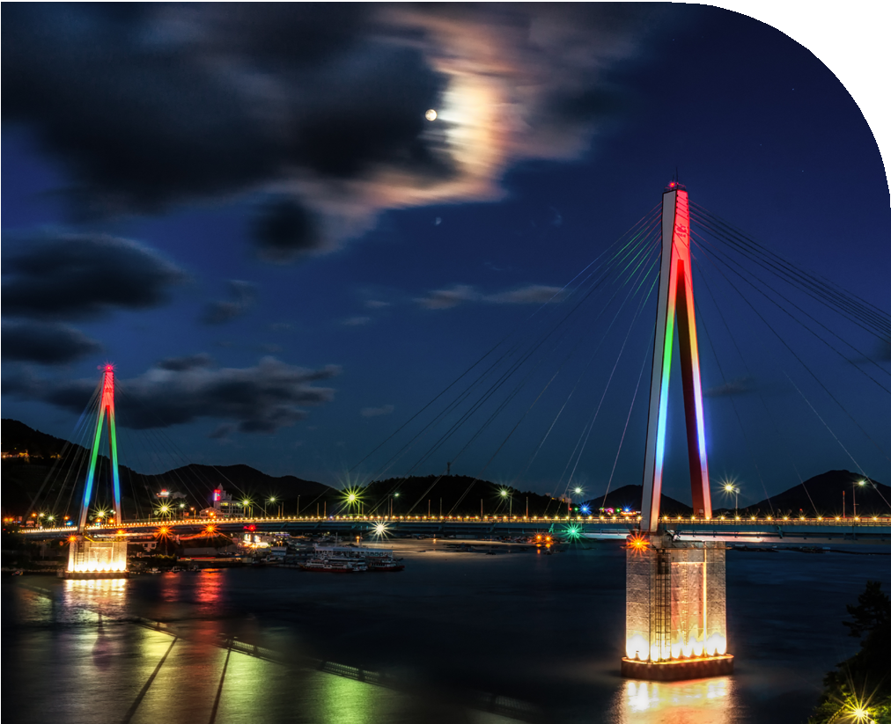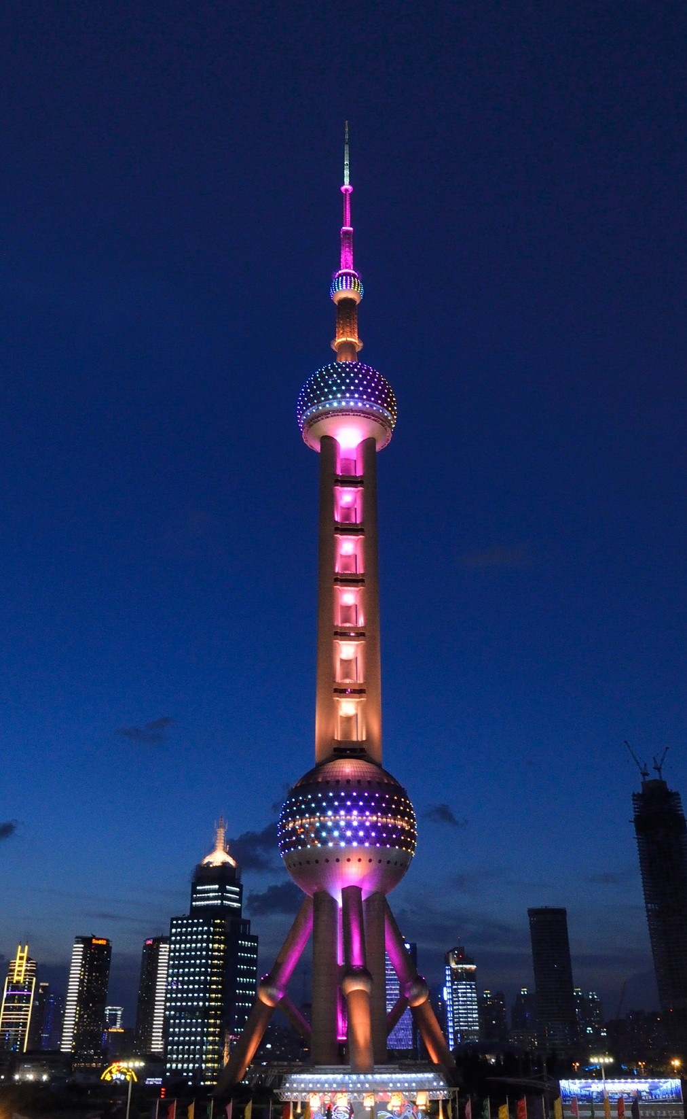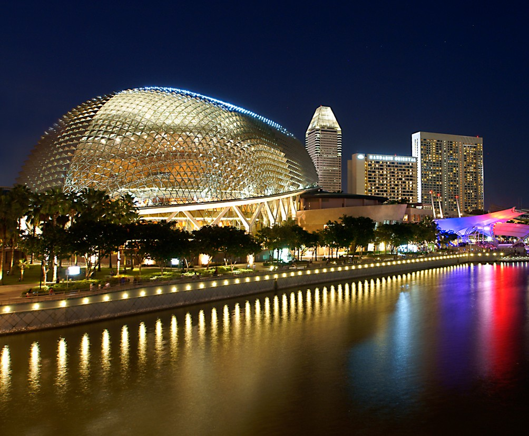SECTION 09 96 13
FIELD-APPLIED FLUOROPOLYMER HIGH PERFORMANCE
LATEX COATINGS
FOR FAÇADE RESTORATION
THIS GUIDE SPECIFICATION IS WRITTEN ACCORDING TO CSI SECTIONFORMAT®
FOR THE LATEST UPDATES, PLEASE VISIT KYNARAǪUATEC.COM
TO SPEAK WITH A KYNAR AǪUATEC® REPRESENTATIVE,
CALL 1-800-KYNAR-50

SeCTION 099600 - HIGH PeRFORMANCe LATeX COATINGS
Disclaimer - Please consult Arkema’s disclaimer regarding the use of Arkema’s products on
http://www.arkema.com/en/products/product-safety/disclaimer/index.html
Kynar®, Kynar 500®, and Kynar Aquatec® are registered trademarks of Arkema Inc.
©2023 Arkema Inc. All rights reserved.
The paint systems specified in this Section are based on the use of Kynar Aquatec® fluoropolymer based coatings as the basis of design.
Kynar Aquatec® fluoropolymer is an innovative platform of emulsions, which are used by paint formulators to make premium weatherable water-based coatings. Coatings formulated with these emulsions can provide the durability and performance of traditional Kynar 500® resin-based coatings. They can easily be applied to a variety of substrates, including metals, plastics, wood, concrete, masonry, fiber cement, stucco, textiles, and previously painted surfaces.

PART 1 - GeNeRAL

  - SUMMARY
    - Section Includes:
      - Field-applied, water-based, fluoropolymer liquid coating system.
      - Field-applied, water-based, fluoropolymer liquid heat reflective coating system.
      - Field-applied, water-based, fluoropolymer liquid coating system for metal substrates.
      - Field-applied, water-based, fluoropolymer liquid coating system for cementitious substrates.
    - Related Requirements:
The list of related sections below is only an example. If including the Related Section paragraph, be sure to delete section from the list below that are not part of the project, and add sections which are part of the project but not listed. Verify section titles.
      - Division 01 Section "Sustainable Design Requirements".
      - Division 03 Section "Tilt-Up Concrete".
      - Division 04 Section "Unit Masonry".
      - Division 05 Section "Decorative Metal Panels".
      - Division 06 Section "Rough Carpentry".
      - Division 06 Section "Plastic Fabrication".
      - Division 07 Section "Metal Wall Panels".
      - Division 07 Section "Sheet Metal Flashing and Trim".
      - Division 08 Section "Louvers and Vents".
      - Division 09 Section "Cement Plastering".
      - Division 13 Section "Metal Building Systems".

  - DeFINITIONS

HIGH PeRFORMANCe LATeX COATINGS 099600 - 2

    - The Kynar Aquatec® platform of emulsions
      - Kynar Aquatec® ARC latex: Hybrid dispersion containing 70% by weight Kynar® fluoropolymer resin and 30% acrylic resin.
Kynar Aquatec® ARC latex is a hybrid dispersion containing, on polymer solids, 70% by weight Kynar® fluoropolymer resin and 30% proprietary acrylic resin. This ratio is similar to those used in baked metal finishes based on Kynar 500® fluoropolymer, which have over a 50-year track record of superb weatherability in architectural applications. After 20 years south Florida exposure, waterborne coatings based on prototype versions of Kynar Aquatec® ARC latex have weathering performance comparable to 70% Kynar 500® fluoropolymer finishes.
      - Kynar Aquatec® FMA-12 Latex: Hybrid dispersion containing 50% by weight Kynar® fluoropolymer resin and 50% acrylic resin

Kynar Aquatec® FMA-12 latex is a hybrid dispersion containing, on polymer solids, 50% by weight Kynar® fluoropolymer resin, and 50% proprietary acrylic resin. Accelerated weathering results confirm superior durability of FMA-12 latex compared to premium grade acrylics. Kynar Aquatec® FMA-12 latex paints are designed for field-applied elastomeric roofing, building restoration and premium architectural coatings. Coatings based on this product show excellent adhesion to numerous substrates including fluoropolymer coated metal roofing.

      - Kynar Aquatec® CRX Latex: Hybrid dispersion containing 70% by weight Kynar® fluoropolymer resin and 30% acrylic resin with hydroxyl functionality
Kynar Aquatec® CRX latex is a hybrid dispersion containing, on polymer solids, 70% by weight Kynar® fluoropolymer resin and 30% proprietary acrylic resin with hydroxy functionality that can be formulated with crosslinkers to provide improved hardness, solvent resistance, and abrasion resistance. The fluoropolymer to acrylic ratio is similar to those used in baked metal finishes based on Kynar 500® fluoropolymer, which have over a 50-year track record of superb weatherability in architectural applications.

    - DMT: Direct to Metal.
    - LEED®: Leadership in Energy and Environmental Design (LEED®) is a sustainable (green) building rating systems developed by U.S. Green Building Council (USGBC).
    - VOC: Volatile Organic Compounds.
    - SRI: Solar Reflective Index.

  - REFERENCE STANDARDS
    - ASTM International (ASTM)
      - ASTM B 117 – Practice for Operating Salt Spray (Fog) Apparatus.
      - ASTM D 610 - Standard Test Method for Evaluating Degree of Rusting on Painted Steel Surfaces.
      - ASTM D 714 - Standard Test Method for Evaluating Degree of Blistering of Paints.
      - ASTM D 1654 – Standard Test Method for Evaluation of Painted or Coated Specimens Subjected to Corrosive Environments.
      - ASTM D 2244 – Test Method for Calculation of Color Differences from Instrumentally Measured Color Coordinates.
      - ASTM D 4214 – Test Methods for Evaluating Degree of Chalking of Exterior Paint Films.
      - ASTM D 4587 - Standard Practice for Fluorescent UV-Condensation Exposures of Paint and Related Coatings.
      - ASTM G 154 - Standard Practice for Operating Fluorescent Light Apparatus for UV Exposure of Nonmetallic Materials.

  - PReINSTALLATION MeeTINGS
    - Section [013000 - Administrative Requirements] <insert section number and title>: Requirements for coordination.
    - Convene minimum one week prior to commencing Work of this Section.
      - Attendees: Contractor, installer, [and manufacturer].
      - Review installation instructions and conditions at Site.

  - SUBMITTALS
    - Section [

1.4 PReINSTALLATION MeeTINGS

>: Requirements

013300 - Submittal Procedures] <insert section number and title
for submittals.
Product data sheets and samples are available from a Kynar Aquatec® coating formulator and can be accessed through the following web site: http://www.KynarAquatec.com.
    - Product Data: Submit data on finishing products and coatings.
Color or colors may actually be specified in other Sections based on various materials and products being painted. Cross reference these Sections.
    - Samples for Initial Selection:
      - Submit [two] [ ] <insert item>, [6 by 6 inches (150 by 150 mm)] [ by
( by )] in size illustrating color, gloss, and texture for each color selected and each material to be coated.
    - Samples for Verification:
      - Submit [two] [ ] <insert item>, [6 by 6 inches (150 by 150 mm)] [ by
( by )] in size illustrating color, gloss, and texture for each color selected and each material to be coated.
Kynar Aquatec® emulsion is a copolymer of vinylidene fluoride. Finishes based on Kynar Aquatec® emulsion are formulated by Kynar Aquatec® trademark licensees and contain, in addition to Kynar Aquatec® emulsion, high quality pigments, and performance additives. According to the licensing agreement, a minimum of 25 percent by weight fluoropolymer resin solids on total resin solids using Kynar Aquatec® emulsion is required. These high quality coating systems have a proven history when exposed to severe ultraviolet radiation for more than 20 years.
Request certificates from the Kynar Aquatec® trademark licensee to ensure that coatings contain Kynar Aquatec® emulsion manufactured by Arkema Inc. at the proper percent of fluoropolymer solids.
    - Certificates: Certify coatings are manufactured with minimum [50%] [25%], by weight, Kynar Aquatec® fluoropolymer resin and meet or exceed specified requirements of this Section.
    - Test and Evaluation Reports:
      - Submit preconstruction adhesion test report.
    - Manufacturers' Instructions: Submit manufacturer's installation instructions.

    - Field Quality Control Submittals:
      - Submit manufacturer's field service report.
    - Sustainable Design Submittals:
      - Section [018113 - Sustainable Design Requirements - LEED® V4] <insert section number and title>: Requirements for sustainable design submittals.
      - Manufacturer's Certificate: Certify products meet or exceed specified sustainable design requirements.
The following are for LEED V4.
        - Building Life-Cycle Impact Reduction, Option 3.
        - Persistent, Bioaccumulative, and Toxic (PBT) Source Reduction - Lead and Cadmium.
          - Certify reduction of these materials.
    - Qualification Statements: Submit manufacturer's qualifications.

  - CLOSEOUT SUBMITTALS
    - Section [017000 - Execution and Closeout Requirements] <insert section number and title>: Requirements for submittals.
    - Operation and Maintenance Data: Submit data on cleaning, touch-up, and repair of painted and coated surfaces.

  - MAINTENANCE MATERIALS
    - Section [017000 - Execution and Closeout Requirements] <insert section number and title>: Requirements for maintenance materials.
    - Supply [1 quart (1 L)] [1 gallons (4 L)] <insert quantity> of each color, type, and surface texture; store where directed.
    - Label each container with color, type, [texture], locations, [items coating was applied to] in addition to manufacturer's label.

  - QUALITY ASSURANCE
Retain one of the 2 Manufacturer Qualification options and delete the other. Keep the 2nd option for a non-proprietary, publicly bid project.
    - Manufacturer Qualifications: Company specializing in the manufacture of coatings specified in this Section that is a [Kynar Aquatec® licensee] [licensee of the resin manufacturer].
Edit Part 2 Products before editing the Applicator Qualification requirements below.
    - Applicator Qualifications: Company specializing in applications of coatings specified in this Section and is approved by coating manufacturer.

    - Preconstruction Adhesion Testing:
Include adhesion testing to ensure coating compatibility with substrates. This test is for use on metallic substrates. Use on other substrates may not give meaningful results. Adhesion test is destructive. Test area must be repaired after testing.
      - Apply first coat to substrate. Test coating adhesion by ASTM D 3359.
        - Perform minimum three tests.
          - Acceptance Criteria: Minimum 4A, each test.
        - Comply with manufacturer's instructions for meeting specified adhesion.
        - Repeat test until meeting acceptance criteria.
        - Remove or repair damaged coating.

  - DELIVERY, STORAGE, AND HANDLING
    - Delivery and Acceptance Requirements:
      - Deliver materials in manufacturer's original unopened containers with labels intact and legible.
    - Storage and Handling Requirements:
      - Store coatings in a cool dry area.
      - Protect materials against damage by construction traffic.

  - FIELD CONDITIONS
    - Section [016000 - Product Requirements] <insert section number and title>: Environmental conditions affecting products on site.
    - Apply coatings only when temperature of surfaces to be coated and surrounding air temperatures are between 50 to 100 °F (10 and 38 °C). Substrate should be 5 °F above the dew point.
    - Do not apply coatings in snow, rain, fog, or mist. Do not apply coatings if precipitation is expected within 24 hours or if the air or substrate temperature is expected to drop below 35 °F within 48 hours.

  - WARRANTY
    - Section [017000 - Execution and Closeout Requirements] <insert section number and title>: Requirements for warranties.
    - Coating Applicator’s Warranty: Applicator agrees to repair finish or replace coated items that demonstrate deterioration of field-applied high performance latex coatings within warranty period indicated.

      - Tier [1][2] Exposed Coating containing a minimum of [50][25] % of fluoropolymer resin solids from Kynar Aquatec® emulsion based on total resin solids it the formulation. Deterioration includes but is not limited to:
        - Color fading exceeding [5] [10] Delta E Hunter units per ASTM D 2244.
        - Peeling, checking, or cracking of coating adhesion to substrate.
        - Chalking exceeding [No. 6 (Colors)] [No. 8 (Whites)] per ASTM D 4214
      - Warranty Period: [10] [15] [20] years from date of Substantial Completion.

PART 2 - PRODUCTS

  - COATING PERFORMANCE
Select one or more of the following systems according to the project requirements. If selecting more than one system, clearly indicate the limits of each system and identify each system on the drawings.
To meet the performance criteria of a Tier 1 coating, these coatings must contain a minimum of 50% of fluoropolymer resin solids based on the total amount of resin solids in the paint formulation. 50% fluoropolymer resin solids coatings based on Kynar Aquatec® emulsion typically carry the longest term performance warranties from the coatings manufacturer.
Only a coating that contains Kynar Aquatec® emulsion can be branded a Kynar Aquatec® coating and should be clearly labeled with the percent of fluoropolymer resin solids on total resin solids.
    - Tier 1: Kynar Aquatec® emulsion-based, field-applied, water-based, fluoropolymer liquid coating system on existing roof and exterior surfaces that comply with the following performance criteria:
      - After 4000 hours of QUV-B exposure per ASTM G154 cycle 2 with UVB-313 lamps and a minimum irradiance of 0.67 W/m2/nm, or a modified cycle 2 with UVB-313 lamps, 8 hours UV at 60 (+/- 3) °C black panel temperature; 4 hours condensation at 50 (+/- 3) °C black panel temperature and a minimum irradiance of 0.67 W/m2/nm, the exposed coating deterioration does not exceed the following criteria:
        - Color fading exceeding 5 Delta E Hunter units per ASTM D 2244.
        - Peeling, checking, or cracking of coating adhesion to substrate.
        - Chalking exceeding No. 6 (whites) or No. 8 (colors) when tested per ASTM D 4214.
To meet the performance criteria of a Tier 2 coating, these coatings must contain a minimum of 25% of fluoropolymer resin solids based on the total amount of resin solids in the paint formulation. 25% fluoropolymer resin solids coatings based on Kynar Aquatec® emulsion and routinely outperform acrylic coatings.
Only a coating that contains Kynar Aquatec® emulsion can be branded a Kynar Aquatec® coating and should be clearly labeled with the percent of fluoropolymer resin solids.
    - Tier 2: Kynar Aquatec® emulsion-based, field-applied, water-based, fluoropolymer liquid coating system on existing roof and exterior surfaces that comply with the following performance criteria:

      - After 4000 hours of QUV-B exposure per ASTM G154 cycle 2 with UVB-313 lamps and a minimum irradiance of 0.67 W/m2/nm, or a modified cycle 2 with UVB-313 lamps, 8 hours UV at 60 (+/- 3) °C black panel temperature; 4 hours condensation at 50 (+/- 3) °C black panel temperature and a minimum irradiance of 0.67 W/m2/nm exposed coating deterioration includes but is not limited to:
        - Color fading exceeding 10 Delta E Hunter units per ASTM D 2244.
        - Peeling, checking, or cracking of coating adhesion to substrate.
        - Chalking exceeding No. 6 (whites) or No. 8 (colors) when tested per ASTM D 4214.

  - SUSTAINABLE DESIGN REQUIREMENTS
LEED® V4 applies to exterior, although only Healthcare and Schools. Confirm compliance with CDPH room testing and CARB 2007 or SCAQM Rule 1113.
    - Environmental Quality Credit: Low-Emitting Materials, Paints.
    - Material Resources Credit: Building Life-Cycle Impact Reduction, Option 3.
      - Coating allows existing [roofs] [and] [walls] to be retained rather than replaced with new materials.
    - Material Resources Credit: Persistent, Bioaccumulative, and Toxic (PBT) Source Reduction - Lead and Cadmium.

  - COATINGS, GENERAL
    - General: [Spray] [Roller] [Brush]-applied, water based, Kynar Aquatec® based, fluoropolymer finish using manufacturer's recommended equipment.
      - Resin: Polyvinylidene Fluoride fluoropolymer.
Always keep the Resin Manufacturer paragraph below. Each fluoropolymer coating system must contain Kynar Aquatec® fluoropolymer.
Kynar Aquatec® is an innovative platform of emulsions, which are used by paint formulators to make premium weatherable water-based coatings. Coatings formulated with these emulsions can provide similar durability and performance of traditional Kynar 500® resin-based coatings. They can easily be applied to a variety of substrates, including metals, plastics, wood, concrete, masonry, fiber cement, stucco, textiles, and previously painted surfaces.
    - Manufacturer, Resin: Subject to compliance with requirements, provide coating systems containing Kynar Aquatec® fluoropolymer by Arkema Inc.
See www.kynaraquatec.com for an up to date list of coatings.
    - Composition: Coating compositions produced by a Kynar Aquatec® Licensee that contains resin solids, where at least [50] [25] percent by weight of total resin solids present is Arkema fluoropolymer.

  - METAL ROOF AND WALL fluoropolymer COATING
.
    - NeverFade® coating by APV Engineered Coatings, Inc.

Primer: [W-1500 Universal PrimerTM] [W-1650 Bonding PrimerTM] [2K Corrosion Resistant Epoxy Primer]
      - NeverFade® topcoat.
        - Accelerated Weathering: 3000 hours in accordance with ASTM D 4587.
        - Weight Solids: 39-55%.
        - Solids by Volume: 35-45%.
        - VOC: Less than 100 g/l.

Flat and Low Gloss sheen finish are available as special request.
        - Finish: [Semi-Gloss] [Eggshell].
        - Overall Film Thickness: 5 to 6 mils (0.13 to 0.15 mm) wet.
      - Accessories: As recommended by manufacture of system coating.
    - Acrymax® fluoropolymer coating by Acrymax Technologies Inc.
      - Primer: Acrymax® PC-535 direct-to-metal elastomeric rust inhibitive coating.
        - Accelerated Weathering: 1000 hours in accordance with ASTM G 154.
        - Salt Spray Resistance: 1000 hours, rust 9, and scribe creep 2mm in accordance with ASTM B 117,
        - Rusting: 9 after 840 hours in accordance with ASTM D 610.
        - Failure at Scribe: 2 mm after 500 hours in accordance with ASTM D 1654.
        - Blistering Resistance: None in accordance with ASTM D 714.
        - Weight Solids: 58-62%.
        - Solids by Volume: 48-52%.
        - VOC: Less than 50 g/l.
        - Dry Film Thickness: 7 to 10 mils (0.18 to 0.25 mm).
      - Top Coat: Acrymax® AF-5500 fluoropolymer coating.
        - Solids by Volume: 43%.
        - VOC: Less than 250 g/l.
        - Dry Film Thickness: 6 mils (0.15 mm).
This coating is designed as a thin filmed finish to protect existing substrate. Gloss level can be controlled with flattening additives for this coating.
      - Clear Coat: Acrymax® AF-4200 clear fluoropolymer coating.
        - Weight Solids: 35-39%.
        - Solids by Volume: 28-32%.
        - VOC: Less than 200 g/l.
        - Dry Film Thickness: 2 to 3 mils (0.05 to 0.08 mm).
        - Sheen: As selected by Architect.

Color or colors may actually be specified in other Sections based on various materials and products being painted. Cross reference these Sections.

Color: [As selected by Architect] [As indicated on Finish Schedule] [Match Architect's sample] [Match existing <insert name of existing surface or product to be matched>]
<insert specific color name and number>.

  - [CEMENTITIOUS AND] OTHER SURFACES FOR fluoropolymer COATING

    - NeverFade® coatings by APV Engineered Coatings.
      - W-1500 Universal Primer, W-1400 Elastomeric Primer.
      - NeverFade® topcoat.
        - Weight Solids: 39-55%.
        - Solids by Volume: 35-45%.
        - VOC: Less than 100 g/l.
Flat and Low Gloss sheen finish are available as special request.
        - Finish: [Semi-Gloss] [Eggshell].
        - Overall Film Thickness: 5 to 6 mils (0.13 to 0.15 mm) wet.
      - Accessories: As recommended by manufacture of system coating.
Color or colors may actually be specified in other Sections based on various materials and products being painted. Cross reference these Sections.

Color: [As selected by Architect] [As indicated on Finish Schedule] [Match Architect's sample] [Match existing <insert name of existing surface or product to be matched>] <insert specific color name and number>.

PART 3 - EXECUTION

  - EXAMINATION
    - Section [013000 - Administrative Requirements] <insert section number and title>: Verification of existing conditions before starting work.
    - Examine coating substrates and correct conditions that would adversely affect appearance or performance of coating system.
    - Correct unsuitable conditions before proceeding with surface preparation and coating application.

  - PREPARATION
    - Protection of In-Place Conditions: Prior to surface preparation and application operations, completely mask, remove or otherwise adequately protect window frames, flashings, hardware, accessories, plates, and similar items in contact with coating surfaces but not scheduled to receive special coating.
    - Metal Surface Preparation:

      - Clean and dry surfaces, free of contaminations such as mildew, dirt, grease, oils, chalk and any other contamination that can affect adhesion prior to application.
      - Remove loose, flaking or oxidized paint from surface by water blasting, wire brushing, grinding, or scraping. Smooth out high and low points to prevent visual uneven coating. Sand blast excessive layers or unevenness.
      - Remove rust by sandblasting or other mechanical means.
      - Remove mold, mildew, and fungi using a bleach solution prior to applying coating system.
      - Repair cracks, holes, roof seams, flashing seams and joints of existing substrate with manufacturer's approved sealant tape.
      - Tighten and replaces loose or corroded fasteners and seal, as needed. Seal joints and seams with manufacturer's approved sealant.

    - Other Substrate Preparations:
      - General:
        - Clean and dry surfaces, free of contaminations such as mildew, dirt, grease, oils, and any other contamination that can affect adhesion prior to application.
        - Remove loose, flaking or oxidized paint from surface by water blasting, wire brushing, grinding, or scraping.
      - Masonry: Properly cured, dry and free of laitance. Smooth and free of ridges and depressions.
      - Wood: Smooth surfaces, free of protruding nails, depressions, or raised edges. Fill damaged areas.
      - Stucco: Smooth, dry, and free of uneven joints between panels. Remove loose or powdery surfaces and repair as necessary. Allow new stucco to cure for 30 days prior to priming and painting.
      - Fiber Cement: Smooth, dry and free of uneven joints between units. Remove loose or peeling paint. Pressure wash surfaces as needed, and allow to dry for two days prior to priming and painting.
      - CMU: Fill voids and cracks and remove ridges and fins, leaving a smooth, clean surface

  - APPLICATION FOR METAL
    - Apply coating system in accordance with manufacturer's written instructions.
    - Apply primer[s] to thickness in accordance with manufacturer’s instructions.
      - Apply a test area of bonding primer and allow to cure overnight. Then test adhesion by cross hatch method. If poor adhesion, use mechanical abrasion method best suited for best results, and retest.
    - Apply sufficient material to achieve minimum dry film thickness in accordance with manufacturer's written instructions.
      - No less than two coats in accordance with manufacturer's written instructions.
    - Keep equipment clean and in proper condition.

    - Apply materials evenly spread and smoothly apply, free of runs, sags, holidays, lap marks, air bubbles and pinholes to assure a smooth finish.

  - APPLICATION, [WOOD] [STUCCO] [VINYL] [MASONRY] [CMU] [FIBER BOARD]
    - Apply in accordance with manufacturer's written instructions.
    - Apply sufficient material to achieve minimum dry film thickness in accordance with manufacturer's written instructions.
    - Complete waterproof of retaining walls and planter boxes prior to applying coating system.
    - Keep equipment clean and in proper condition.
    - Apply materials evenly spread and smoothly apply, free of runs, sags, holidays, lap marks, air bubbles and pinholes to assure a smooth finish.

  - FIELD QUALITY CONTROL

Section [014000 - Quality Requirements] [017000 - Execution and Closeout Requirements]
<insert section number and title>: Field inspecting, testing, adjusting, and balancing.
    - Manufacturer's Field Services:

Section [014000 - Quality Requirements] <insert section number and title>:
Requirements for manufacturer’s field services.
      - Request manufacturer's presence before, during, and after installation to review procedures and completed work, and issue warranty specified.
      - Repair unsatisfactory conditions disclosed by manufacturer's site visits, and re-inspect by manufacturer before work starts or resumes in affected areas.
    - Inspect coated surfaces for uniform thickness, color and appearance, matching approved samples when viewed from 5 feet (1500 mm) away under normal lighting conditions.
      - Ensure coatings are smooth and free from blemishes impairing serviceability and detract from appearance.

  - CLEANING
    - Section [017000 - Execution and Closeout Requirements] <insert section number and title>: Requirements for cleaning.
    - Clean adjacent construction to remove overspray or roller splatter with mild detergent and rinsed with clean water, prior to coating drying.

END OF SECTION

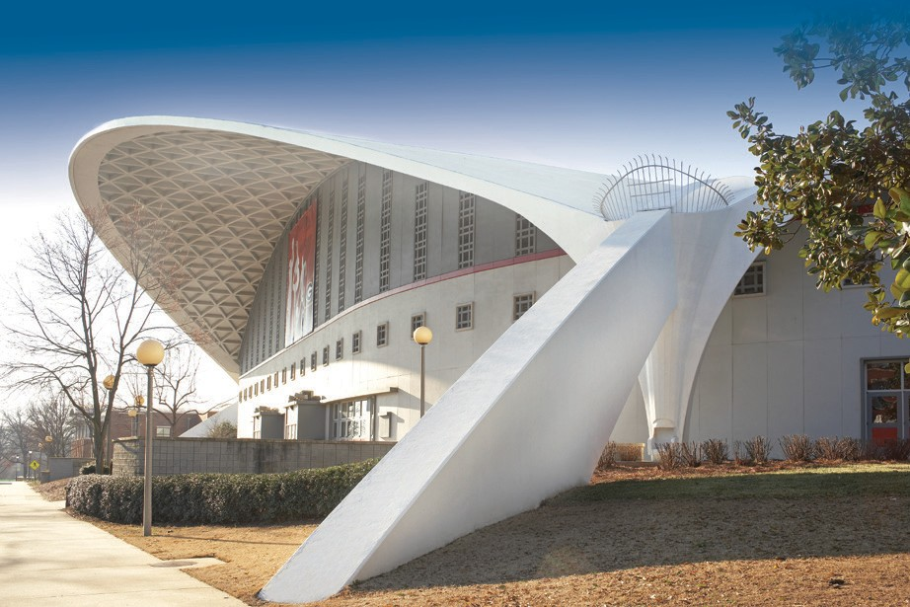
ADV 202205-91 - Design: JG, Images: Arkema, Getty

SUPERIOR PERFORMANCE ARCHITECTURAL COATINGS

→ Fluorosurfactant Free
→ Extreme Weatherability
→ Excellent Dirt Shedding
→ Superb Mildew Resistance
→ > 20 years Florida Exposure

Arkema Inc. 900 1st Ave, King of Prussia, PA 19406
+1 610-205-7000

Headquarters: Arkema France 420 rue d’Estienne d’Orves 92705 Colombes Cedex
France
T +33 (0)1 49 00 80 80

Kynar Aquatec® is a registered trademark of Arkema Inc.
©2023 Arkema Inc. All rights reserved.

Please, consult Arkema’s disclaimer regarding the use of Arkema’s products on https:/ www.arkema.com/global/en/products/product-safety/disclaimer/
Arkema France, a French sociéĒé anonyme registered at the Trade and Companies Register of Nanterre under the number 319 632 790
hpp.arkema.com

